Crosby House Bank

Contents

Analysis 3

Description 3

Stakeholders 4

Why my project is amenable by a computational Approach. 5

Project Research 6

Interview with Primary Stakeholder 6

Interview with Secondary Stakeholder: Nick Cheepchiewcharnchai 7

Similar Solution 1: Barclays Online Banking 8

Similar Solution 2: HSBC Online Banking 15

Similar Solution 3: PayPal.com 20

Similar Solution 4: Local ATM 25

Hardware and Software Requirements 30

Hardware Requirements: 30

Software Requirements: 30

Success Criteria 31

# Analysis

## Description

My project Idea is to create a database for my boarding house that eases the management of the house bank. The Crosby House Bank allows pupils to deposit cash for safe keeping in the house safe and then withdraw the cash in large sums or small amounts . Currently this process is almost completely physical with pupils asking the Housemaster or Deputy Housemaster to withdraw money from the safe. Therefore the aim of my project is to make a web based database that allows pupils to ask for money digitally as well as allowing pupils to check how much money they have in house bank. It will also allow the house master and deputy house master to easily track who has asked to withdraw money and who has deposited money.

## Stakeholders

For my project I intend to have two levels of stake holders:

* **Primary Stake Holder**: Mr Arnold(Deputy Housemaster of Crosby Houser) :
  + Mr Arnold is currently the person in charge of managing the house bank. This means he receives cash from the student and deposits it in house bank as well as giving students money out of house bank when they request cash. This also means he is in charge of tracking how much money each student has in house bank and whether a student has drawn out too much money to the point where they are in debt. The project will allow Mr Arnold to view student balances because this will make it easier for him to view which students are currently in debt and by how much they are in debt. Furthermore, the project will allow him to manage student balances completely electronically by inputting the amount a student has deposited or withdrawn which will make it much easier to control student balances. In addition to this Mr Arnold currently has to tell students in person when they are in debt to house bank and how much money they owe, in person. Therefore this project will allow him to notify students remotely making the process much quicker.
* **Secondary Stakeholder:** Students of Crosby House.
  + The students of Crosby house currently make use of the house bank as it allows them to store cash in safe so that it is secure and then withdraw amounts at a later date. Students also use house bank for convenience. For example, when people come around house collecting money for charity or staff gifts, students can choose to use money from house bank to cover the costs of their donation instead of using Cash. However when students want to take money out of house bank they have to knock on Mr Arnold’s door and ask to take money out of house bank. Therefore my project will allow the students to request money out of house bank remotely via the house bank website. In addition to this students currently do not have any way of checking how much money they have in their house bank. Therefore students will be able to use the house bank website to check their balances in house bank.

## Why my project is amenable by a computational Approach.

* One of the features of my project is that I want to allow individual students to view the amount of money they currently have in house bank without being able to view other people’s accounts. This is amenable by a computational approach as I will need a login system online so that the students can view their own house bank balance and not another students. Furthermore, I will need an admin login so that only Mr Arnold can manage the house bank database and no other person that is not an admin.
* Another feature that my project will have is remote access to their house bank balances. This will be done via a website that Crosby students will be able to acess via their web browser. This is therefore can only be done via a computational approach as a physical approach does not allow students to acess their balances from anywhere they want whereas a computational approach will allow students to access the database online.
* Furthermore another feature that makes my project amenable by a computational approach would be that account balances are automatically updated when a person takes money out of house bank. For example, when a person takes cash out of house bank the amount of money in the safe will also get updated as well as the students account balance. Therefore this can only be done out of a computer as a physical version of this system would require both accounts to be updated individually
* Another feature would be the ability to view multiple account balances at once. For example, if the administrator wanted to view the house bank account they would have to log onto a online banking service but in order to view the cash available in the house safe the admin would have to check a sheet of paper or even count the cash in the safe if the amount is not regularly updated.

## Project Research

#### Interview with Primary Stakeholder

In my interview with Mr Arnold he showed me the current system that was in place which was a very simple database that showed student balances. He then described to me what both the student and administrator needs to be able to do as well as a general explanation of how he wants the system to work. Below is the notes I took while talking about the house bank database.

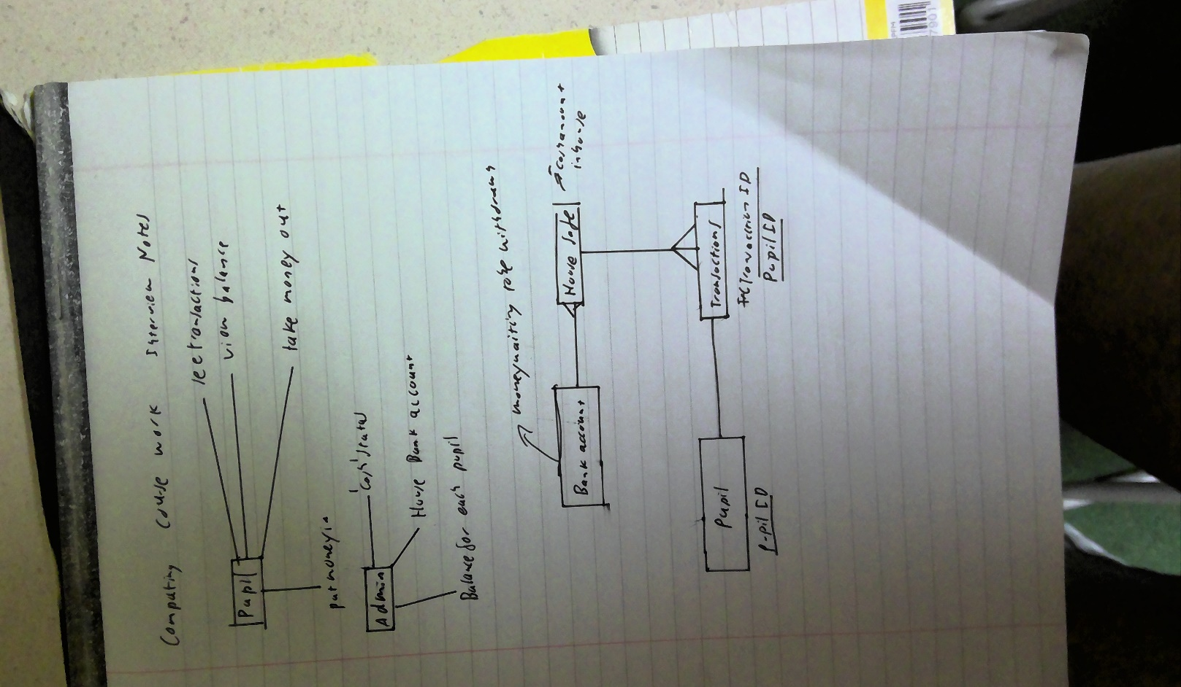

#### Interview with Secondary Stakeholder: Nick Cheepchiewcharnchai

* **How do you currently feel about Crosby house bank**
* House bank is useful to keep large sums of money as it prevents you from losing it. It is good because your parents can transfer in money which you can take out as cash
* **What do you currently use house bank for?**
* I use house bank mainly to take out large sums of money when I run out of cash for taxis. It is also very useful when I want to donate money to charity. For example, with Wyatt carnations I used house bank to cover the 1 pound cost.
* **What are your current problems with house bank?**
* There is no problem when I have to donate money but when I have to take money out myself I have problems because sometimes when I need to get money Mr Arnold is not available for me to get money from him and by the time he is available I forget about needing to take money. I also often forget much money I specifically have in house bank
* **How would you improve Crosby house bank?**
* It would be easier if there was a sheet of paper that Mr Arnold can leave out so that we can request money without disturbing him so that he can see the request and give it to us at dinner. It would also be helpful if there was a place in Crosby where we could see how much money we had in house bank but there would be an issue with privacy of people account balances

### Similar Solution 1: Barclays Online Banking

For this I will be analysing the Barclays banking mobile application. This will allow me to look at how some banking apps are laid out on a mobile phone. All screenshots have been taken from a Barclays Banking video so there is no sensitive information.

**Main Page for Barclays Banking**

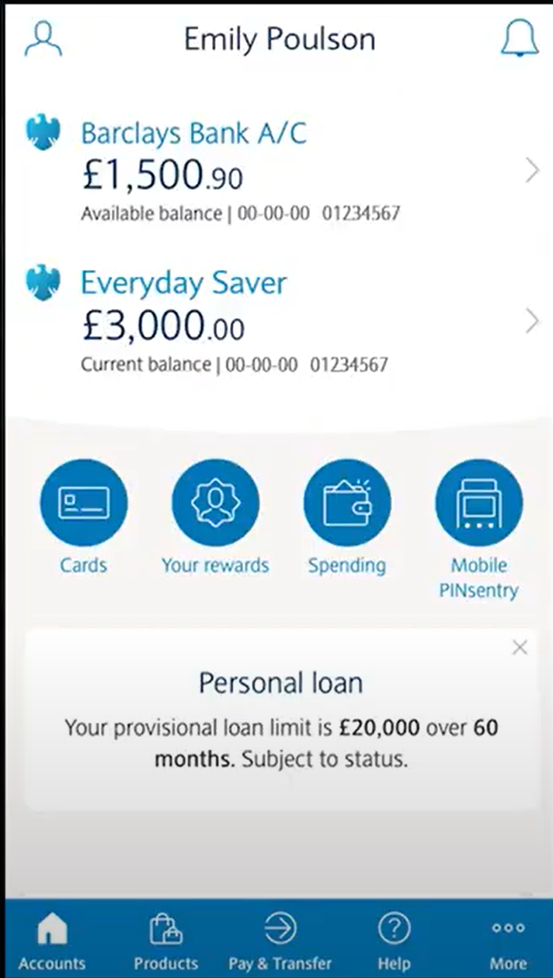

This is a good example of a home page. I like how it displays the balance on the account on the main page. I also like the bar a the bottom allowing to go to different parts of the interface. However I dislike the amount of different features there are on the main page. For my project the website will not offer as many features. For example rewards and products are completely unnecessary features that my project will not offer. In addition I like how there is a help button to explain how to use the website.

**Page Displaying Balance and Transactions.**

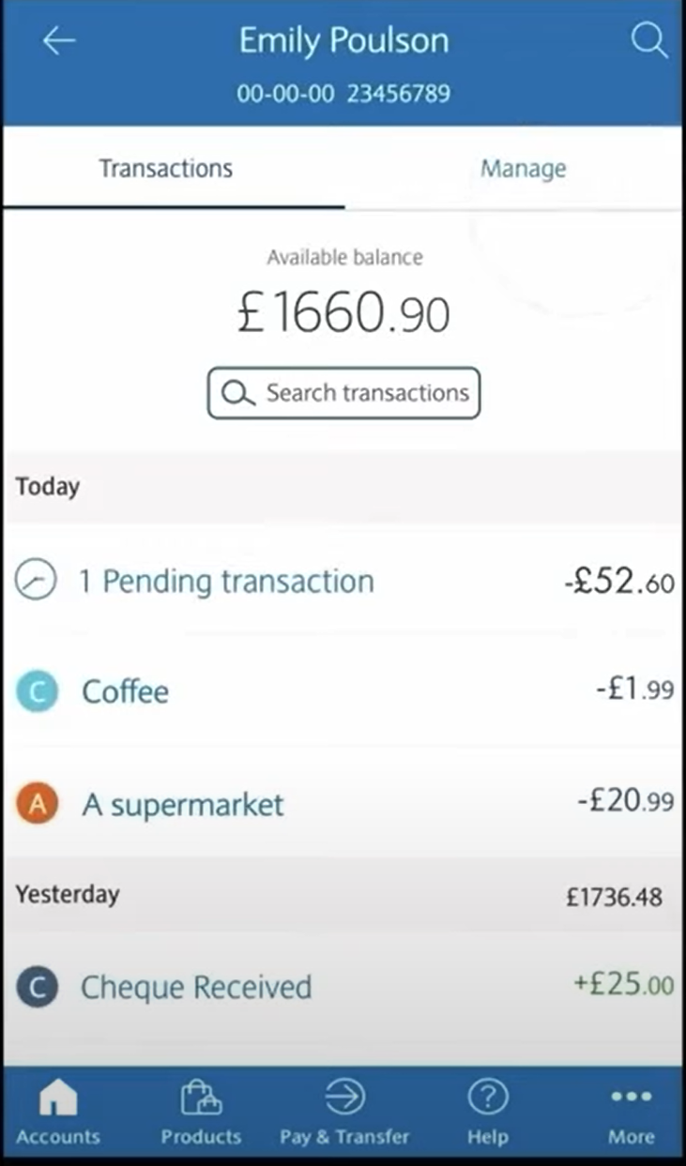

This page displays the account balance. I like the layout of the interface with account balance at the top of the page. I also like how it displays the transaction history of the account with amounts next to the transaction. I also like how it shows what each transaction was for example super market. I think I will use this feature so that the students can keep track of what they used their house bank money for. I do not intend to use a search transactions as it will be to complicated to implement. I also do not intend to allow students to manage their own accounts however the manage an transaction bar will be useful for the administrator to have when viewing student accounts.

**Credit Card Page.**

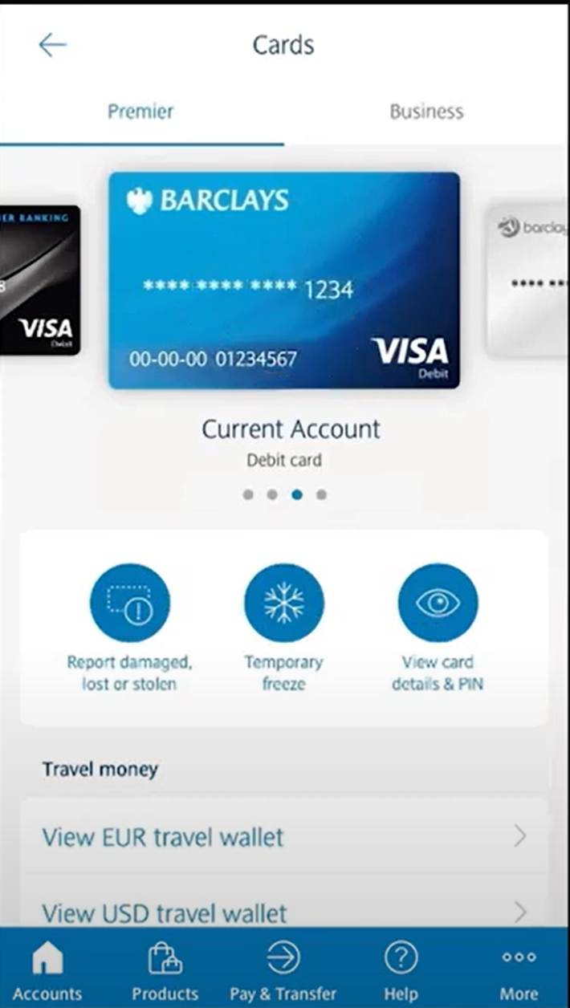

This is a completely unnecessary feature as my project will not use credit or debit cards.

**Login Page for Barclays account**

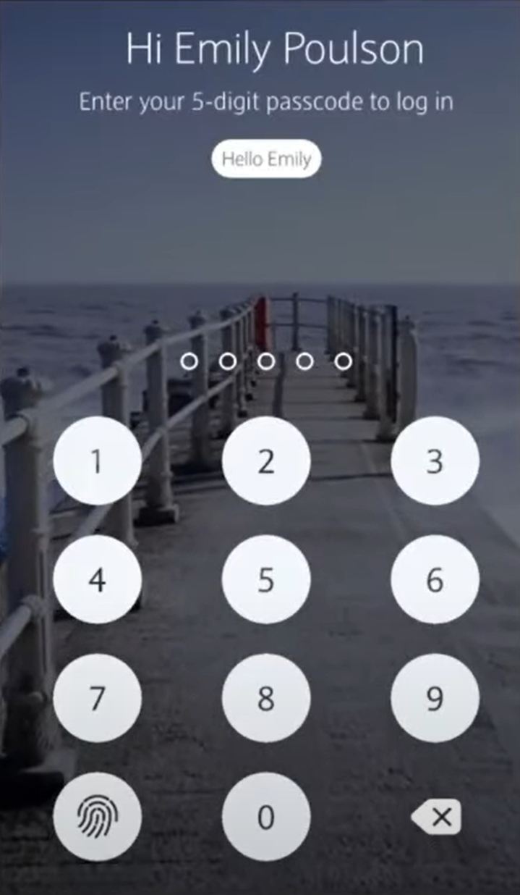

This website uses a 5 digit passcode to login to the online banking system. I do not think I will implement this into my project as this banking system remembers the user so all it needs to do is get confirmation that it is the user logging into the account. However for my project the website will not be able to identify that it is the same user logging on therefore it will need a username and password to login.

**Payment System for Barclays Online Banking**

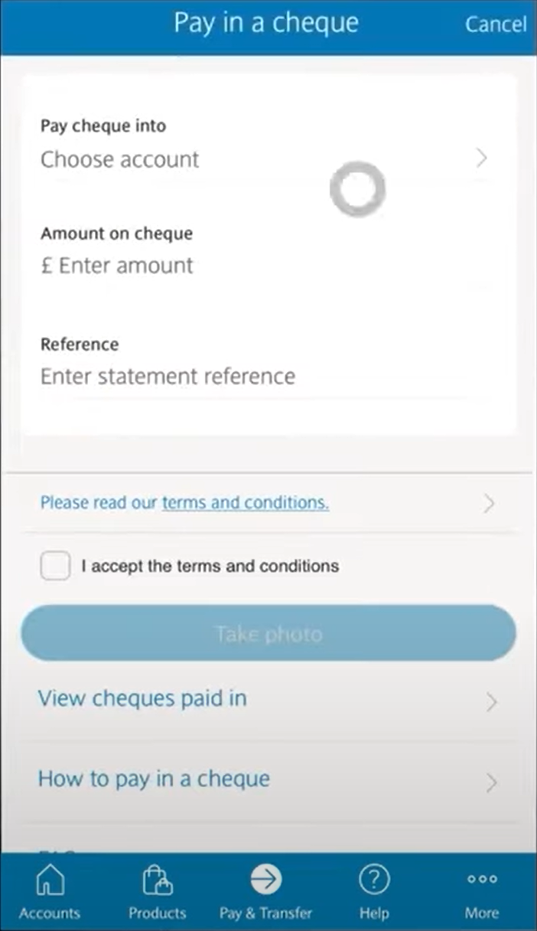

My system will not be using cheques so this is an unnecessary feature.

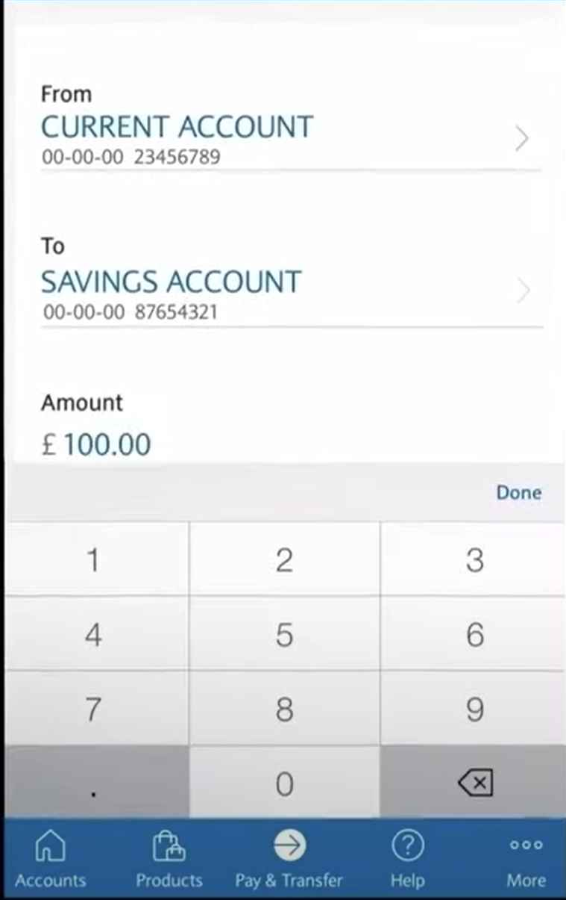

This payment process is much more complicated than the payment process that the house bank will have. This is because for this payment you have to select the account that you want to send from and the account you want to send to. However with my project you will only be dealing with one accounts as you will either be depositing money into house bank or withdrawing money from house bank.

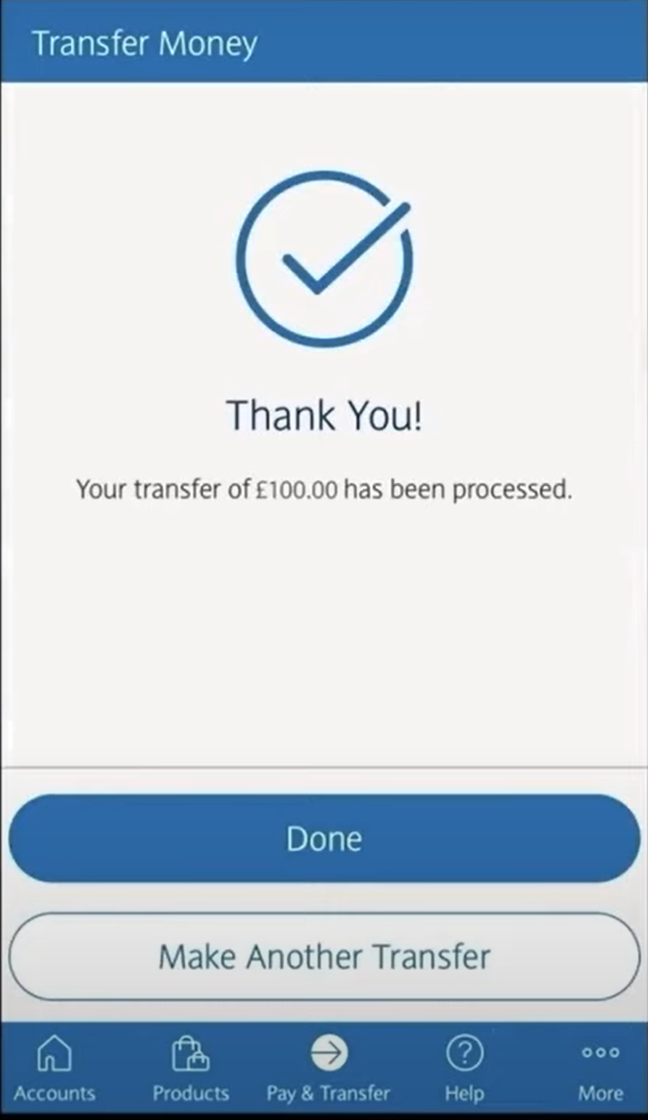

I like this confirmation page as it allows you to make another transfer. Furthermore I like the big tick in the middle of the page and will be implementing this into my project. I will probably use this page as a guide for the completion of payment page.

**Summary of key features Identified:**

* The nav bar at the bottom of the page is a suitable approach to how I would like my website to be displayed on a mobile device as it is simple and only shows the key features.
* The confirmation page is good as it allows the user to make another transfer directly from the page instead of having to repeat the whole process again.
* Additionally, the payment system is very good as you easily choose an account to transfer to and select an amount. This would be very good for transferring money from house bank account to house safe as the date is not required as a detail.

### Similar Solution 2: HSBC Online Banking

HSBC also has an online banking app and website. This provides me a good example of how I might layout my website on a desktop format. It will also provide insight into the functionality of an online banking site.

**Main Banking Page**

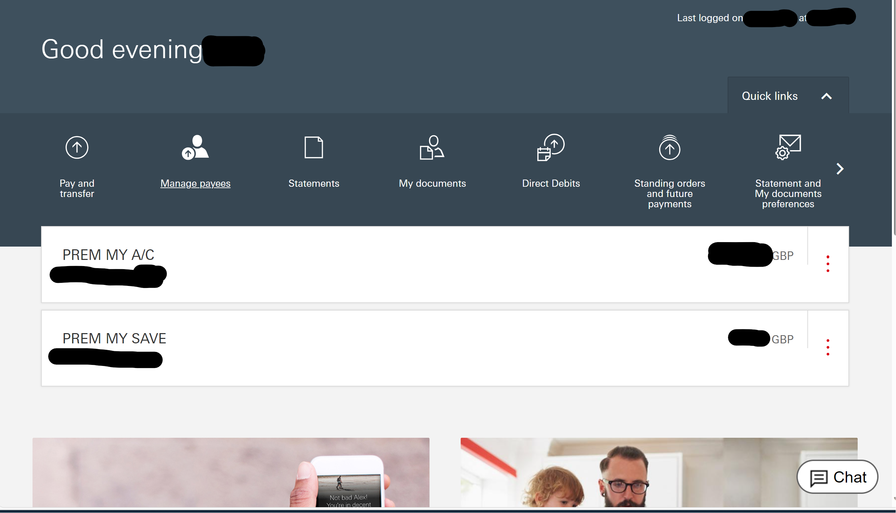

In this image I really like the layout of the menu bar at the top of the screen. Similar to Barclays banking my website will not have as many features so there will not be as many things in the nav bar. I prefer this layout of the navbar at the top of the screen much better than the navbar at the bottom of the screen. However I do not like the collapsable menus as the can cause the website to get quite messy and the colour scheme is very bland. Furthermore I do not like how the menu bar is stays in the upper middle part of the screen instead of the top

**Individual Accounts**

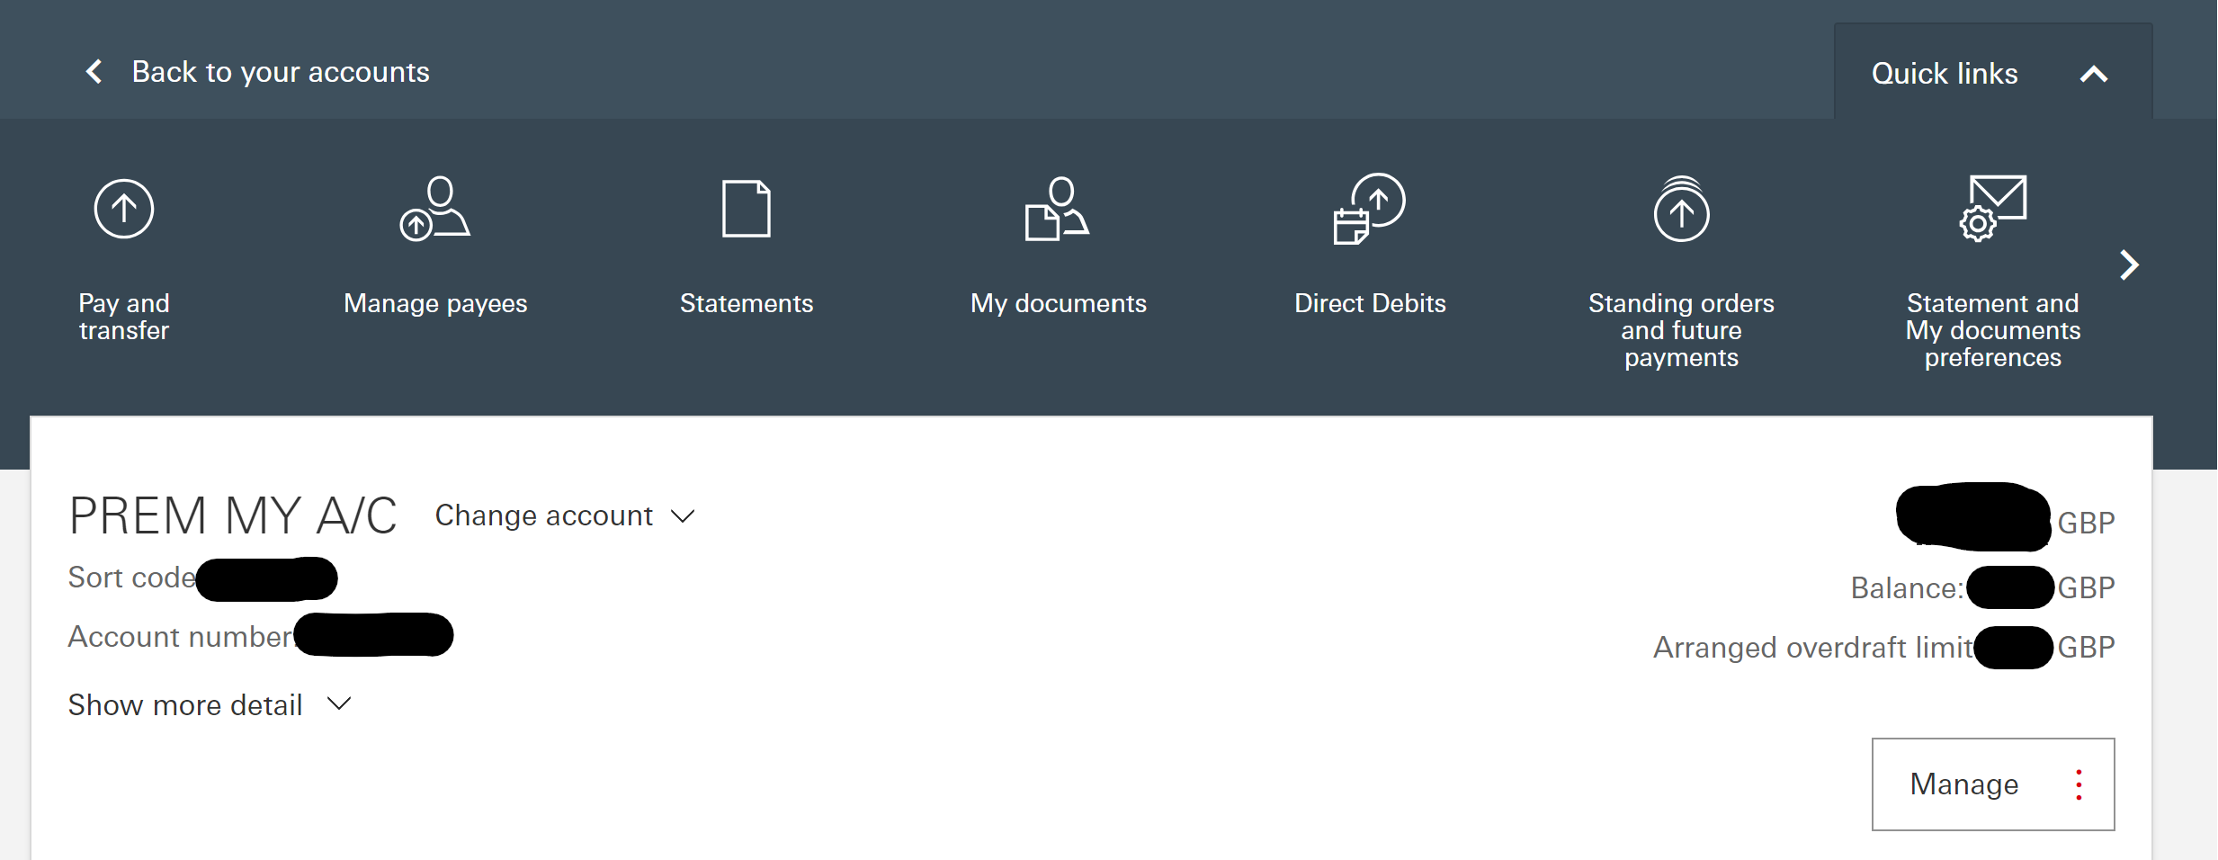

I like the simplicity of the layout. However the dropdown menus again make the website to complicated and means there needs to be a sperate manage button for no reason. I will not implement this.

**Transactions**

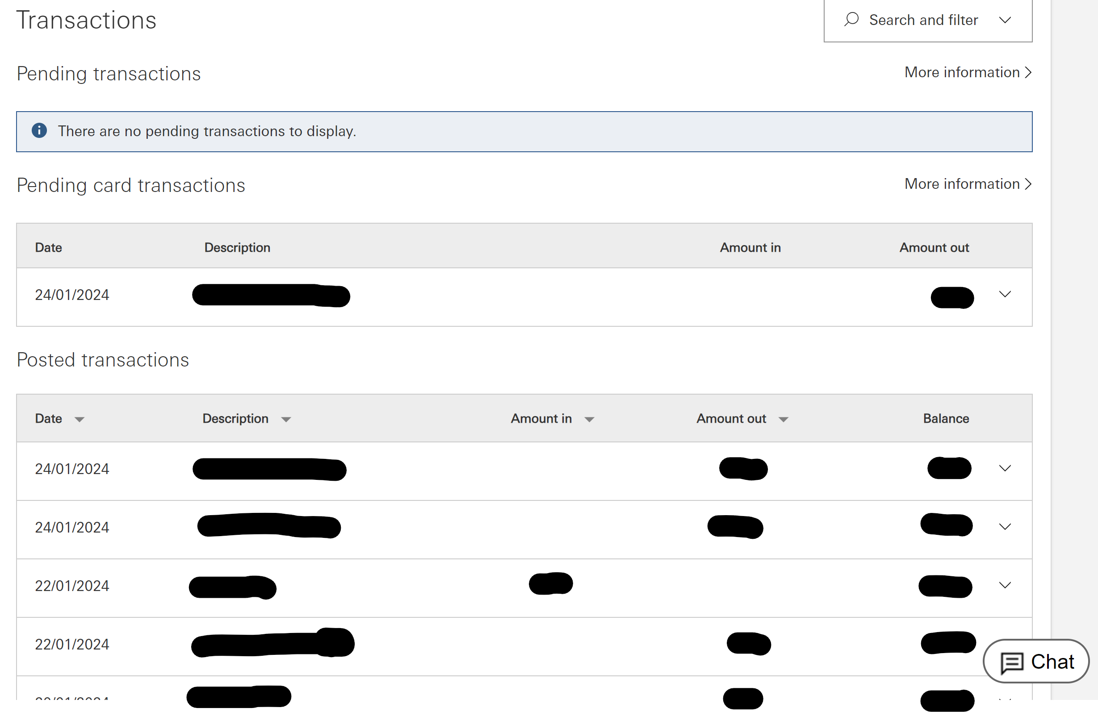

This is a clean layout for tracking transactions and the simplicity something I hope to replicate. Furthermore having pending transactions being able to be viewed and separated from the history. This will be useful in my database as it will allow students to view whether the money they have requested from house bank in cash has gone through. However I don’t think I will have amount out or amount in seperated and will probably just have + or – amounts displayed in transaction history

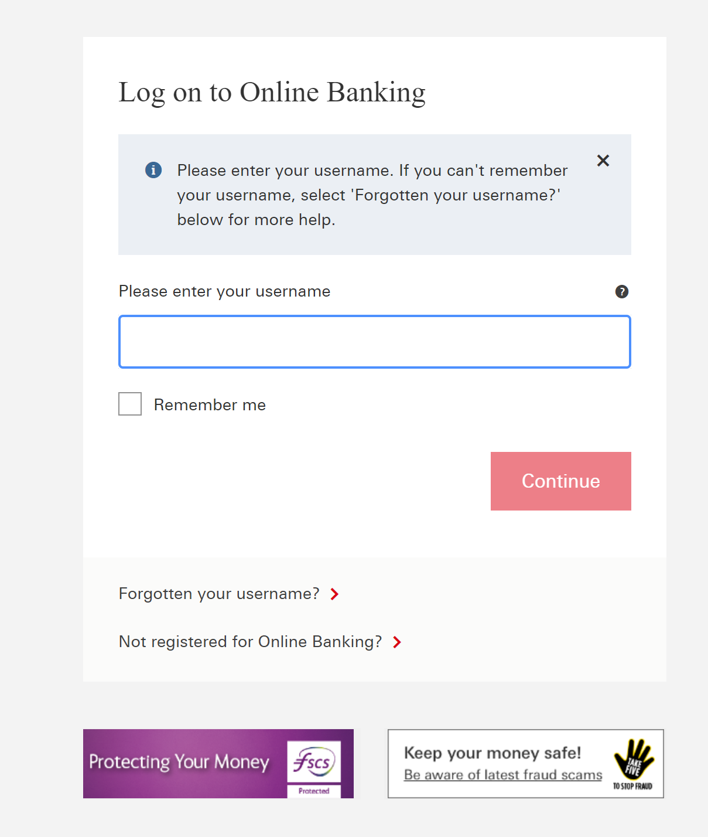

This specific online banking system uses usernames to allow users to log in to the system. This is better than the Barclays method as it does not relay on the device remembering the user. I will implement something like this in my database system.

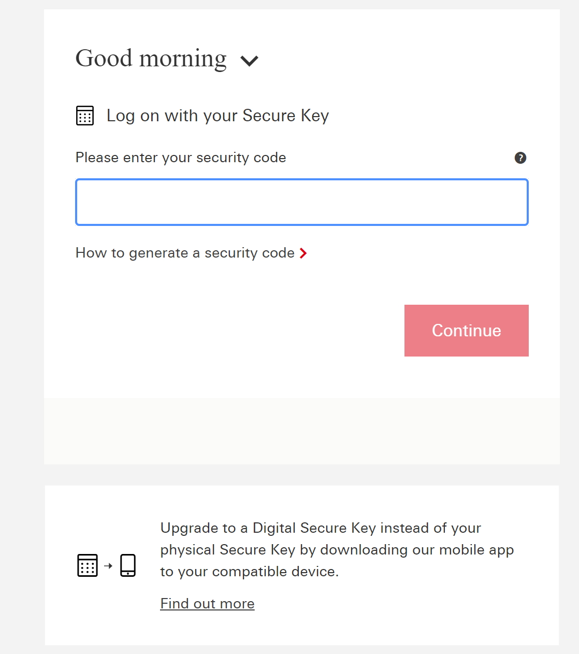

In HSBC and most online banks they require either a digital secure key generated by your phone or by a physical secure key. This is too complicated for my system so I don’t think I will be using this and will stick with a reusable password instead of a one time key that is sent to the user.

**Money Transfer**

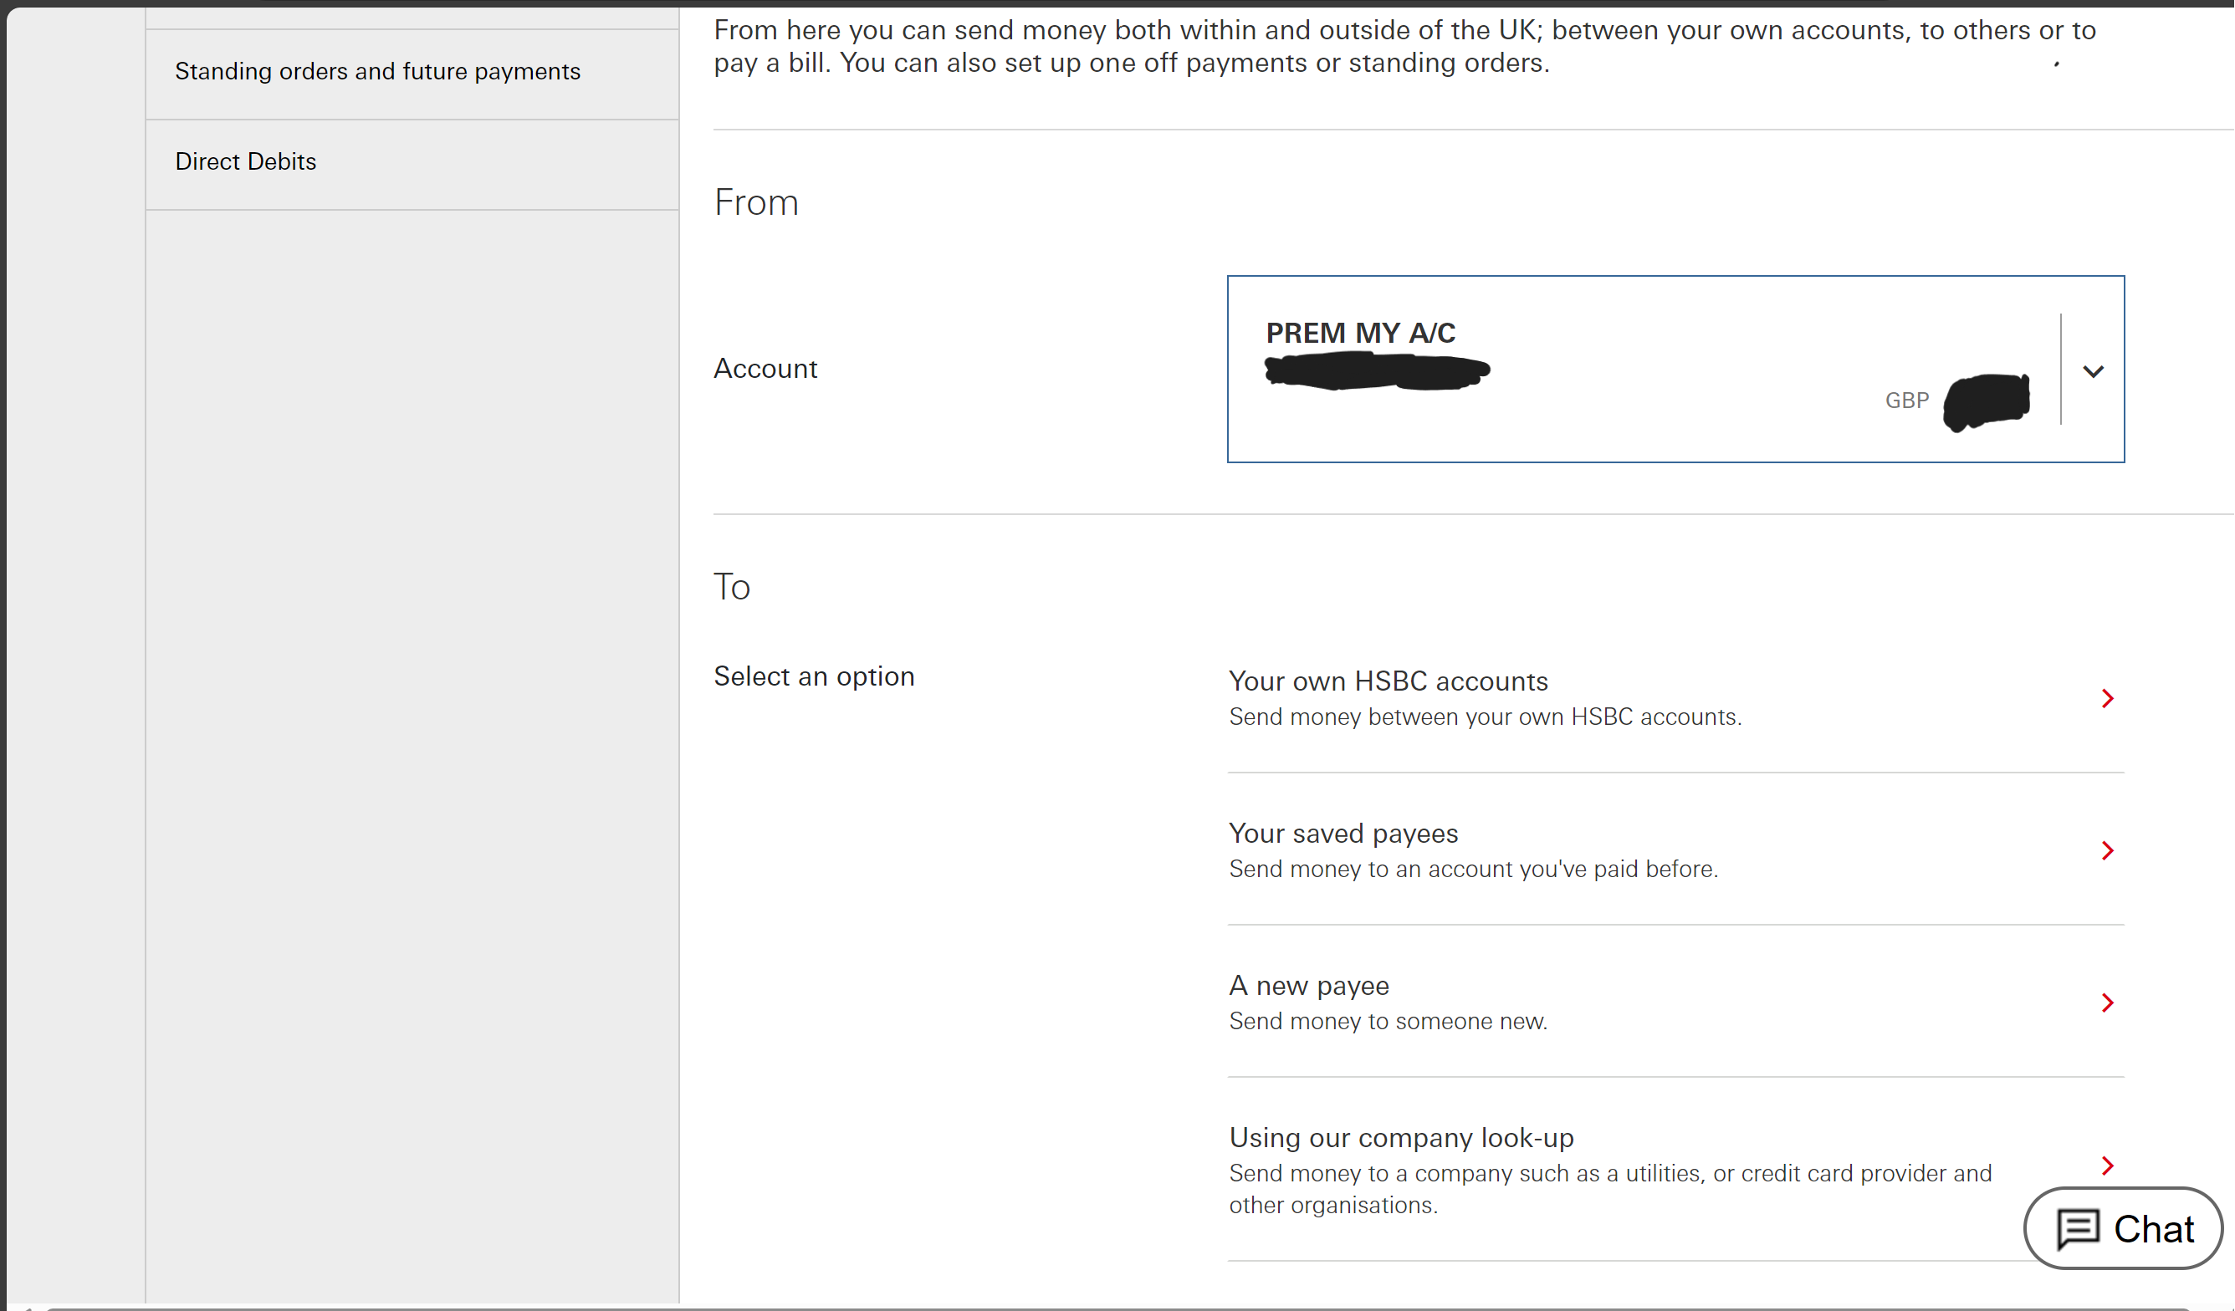

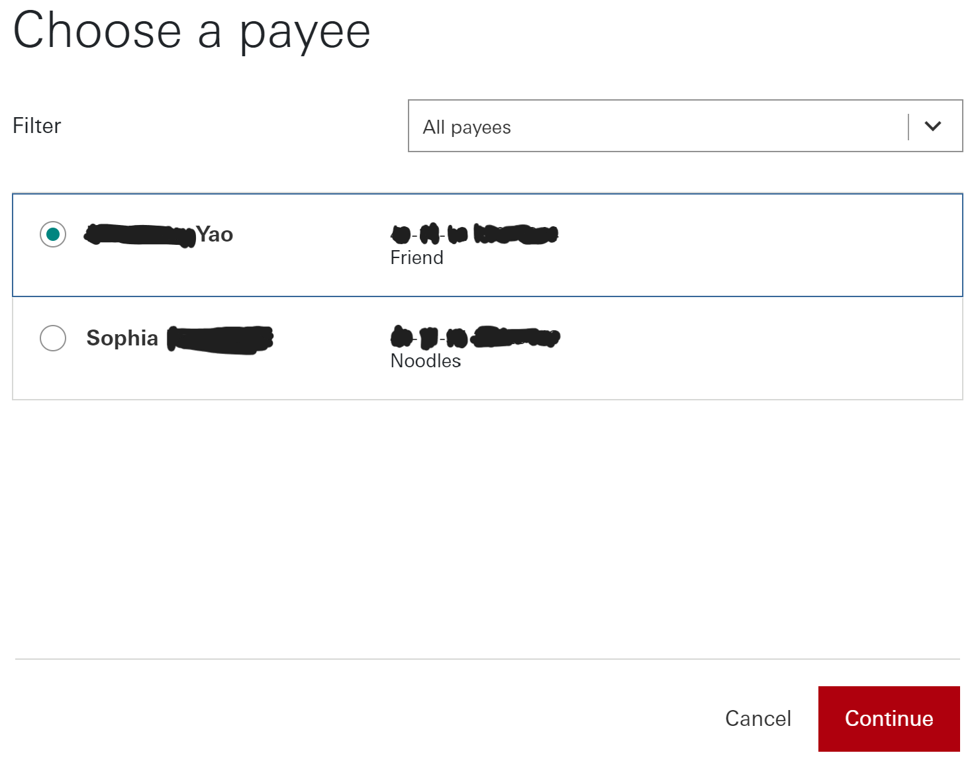

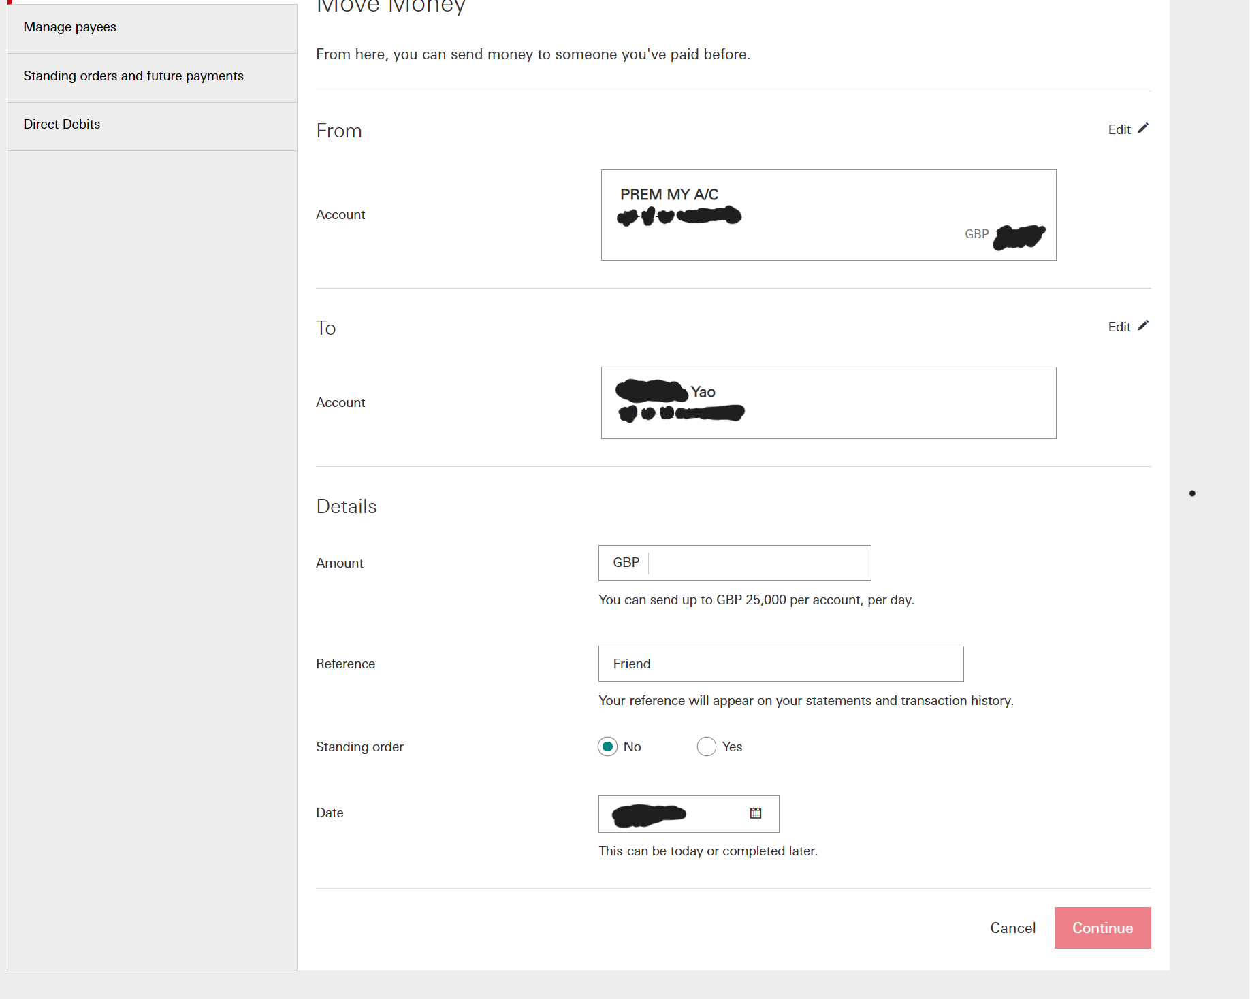

This money transferring system is very effective as it allows users to add a new payee or select a known one. This would be useful when a new set of students join a house as they can easily be added as new payees. Furthermore you can add a reference which will allow the reasons for money transfers to be listed in the transaction history

**Summary of HSBC online banking research**

* One thing that HSBC does very well is the payment system and is something that I wish to replicate. This is because it has a reference and a date that automatically inputs to the current date of the transaction. This would be a good system for tracking how students withdraw money from house bank.
* Another detail that I would implement is the username login system. This will allow pupils to login to the website to show their personal bank accounts.

### Similar Solution 3: PayPal.com

Looking at Paypal.com will give me another perspective of how I might layout my online

**Main Page**

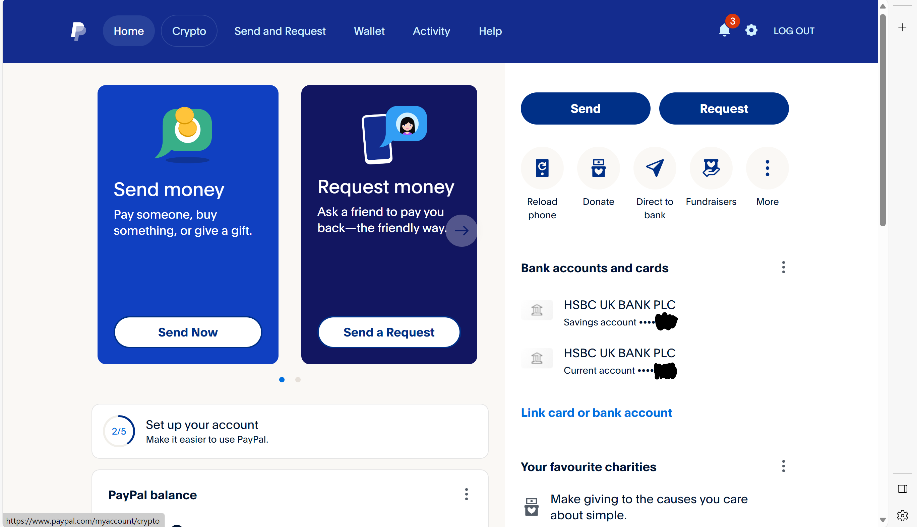

This main page is laid out very well. I like how the two main features of sending or requesting money is in the centre of the page. There is also a lot of useful information on the home page such as balance. I also really like the nav bar at the top the page because it is very simple but has all of the essential features. However the homepage is also cluttered with unnecessary features such as reload phone and fundraisers which are not features that I will be using in my database.

**Sending Money**

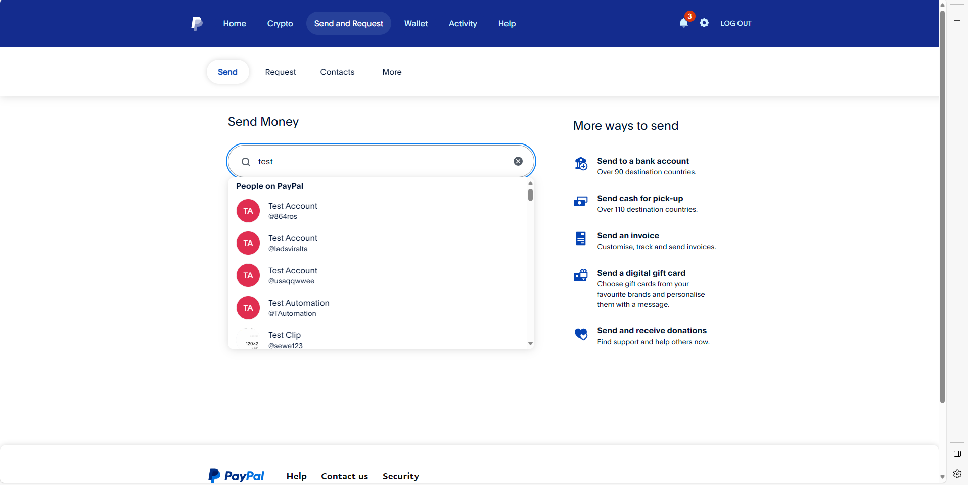

PayPal uses a search bar that allows users to search for other users to send money to. This is not something that I will be using as there are a very small amount of users that the admin needs to have access to as there are a maximum of only 60 students in Crosby.

**Wallet**

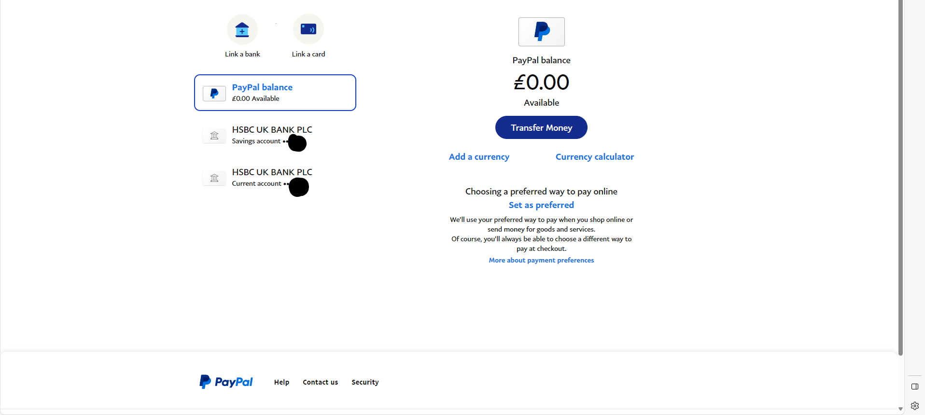

This is not a very good example of a wallet/balance page for my online house bank as there are multiple bank accounts that users have access to on the PayPal website, whereas the users in house only have access to one bank account. Also Crosby house bank will only be done in GBP so multiple currencies are unnecessary.

**Activity**

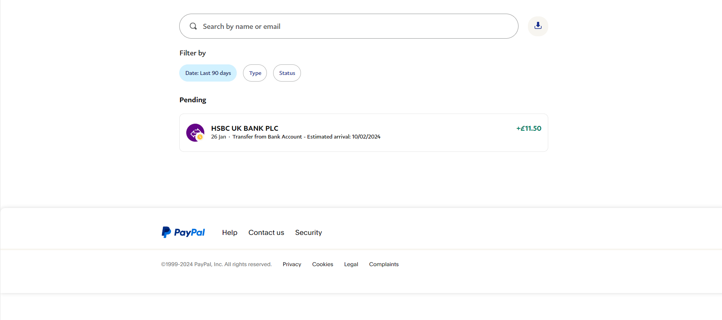



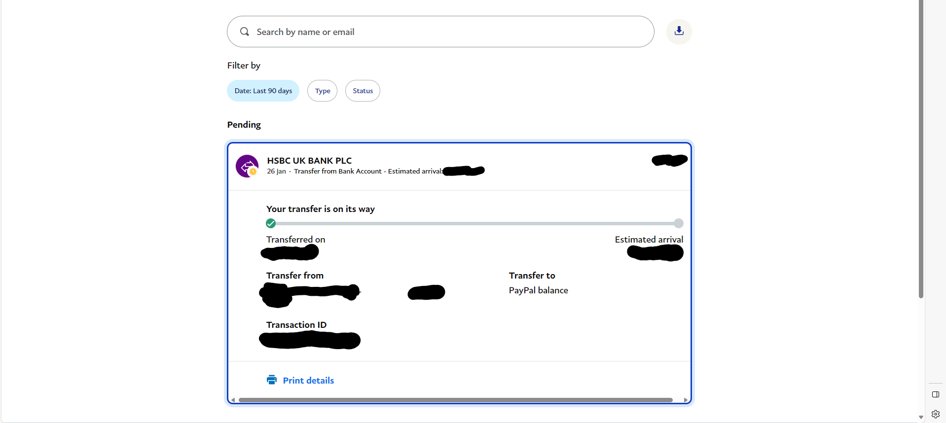

PayPal transactions have a search bar to search through transaction history which I will not be implementing into my database as it is unlikely that the student will have a large number of transactions which require a search bar to navigate. However I do like the dropdown of showing the details of each transaction as it makes the transaction history much tidier.

**Help**

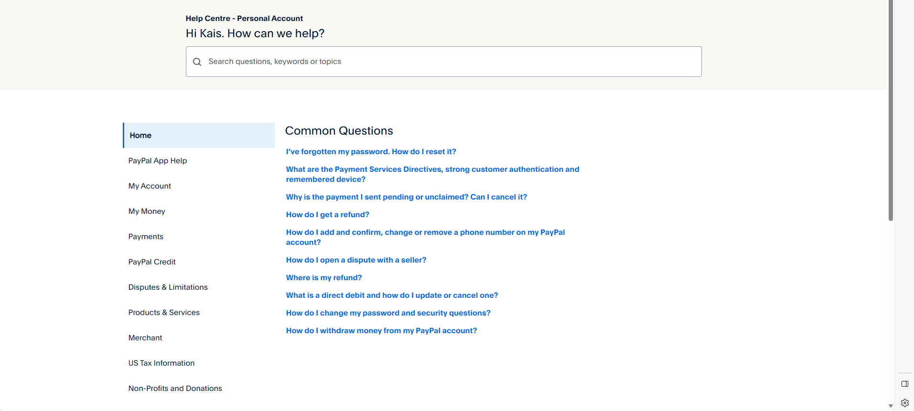

**Summary of PayPal analysis**

* Overall the layout of the PayPal is very appealing.
* One feature of PayPal that I would replicate is the ability to see all accounts that you can transfer. This would be helpful for viewing all of the students in the house and selecting the students account you wish to manage as the administrator.

### Similar Solution 4: Local ATM

Since my system is basically an ATM that is online, I thought looking at a real ATM and analysing the features would be useful to provide some ideas for features of my website.

**Main Page**

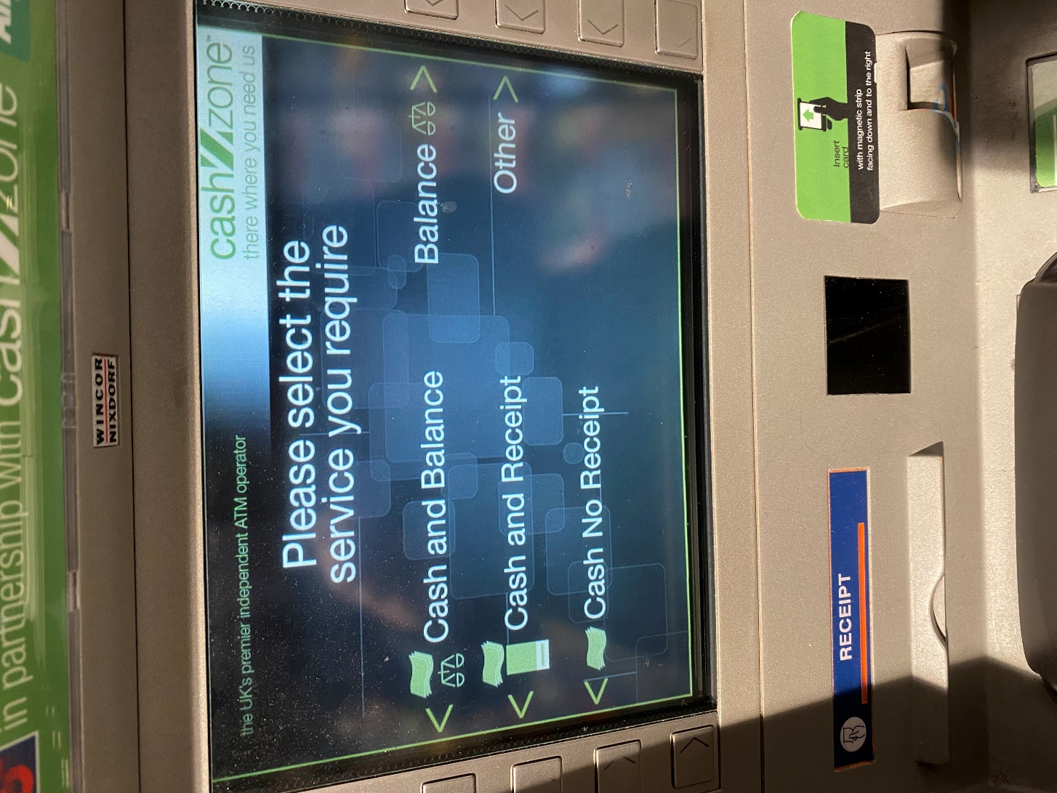

This is a very simple homepage. There are not many features which allows the layout of the homepage to be very simple. However since the ATM is controlled by buttons on the side instead of mouse and keyboard or touch screen it makes the user interface very different inputs on screen have to be in line with the side buttons. Also the colours are very un-appealing.

**Balance Page**

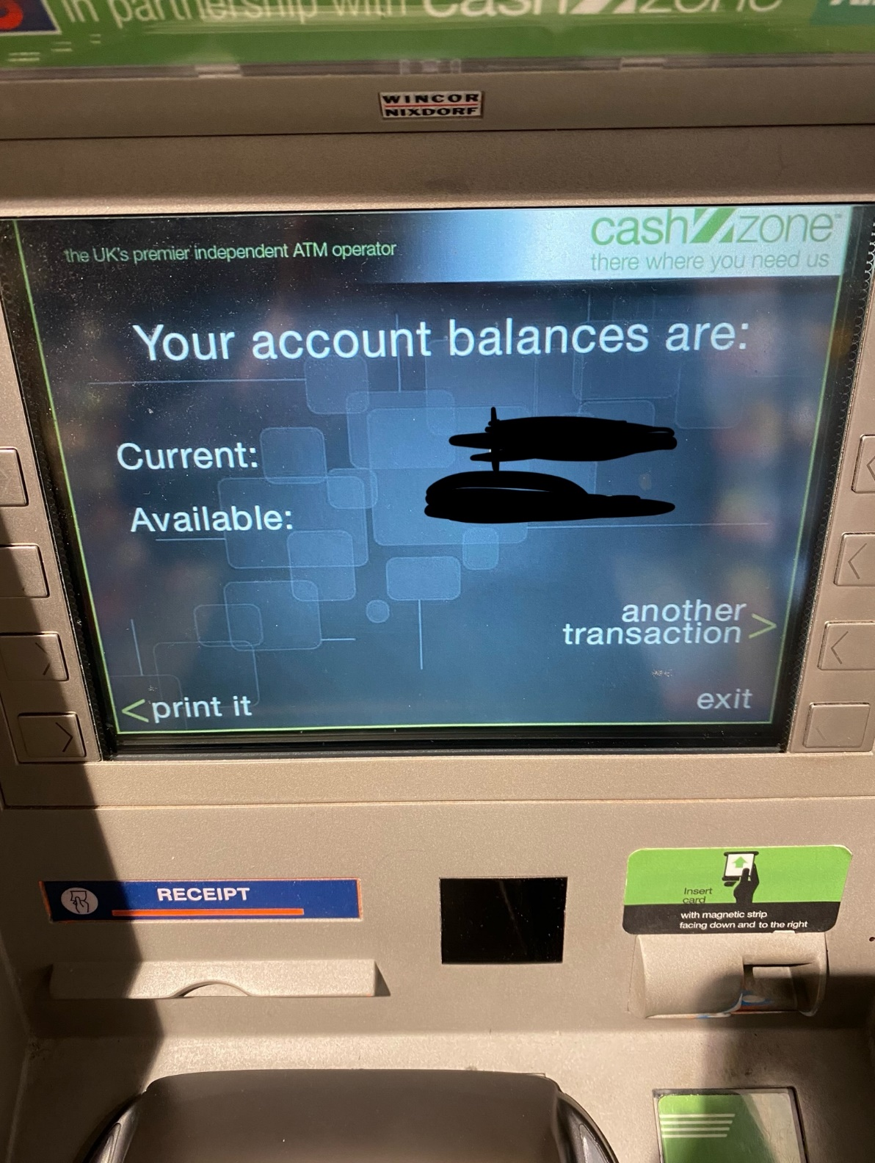

Very Simple. Not many features. Does not display transactions as it is not viewing personal bank account. My website will not have available or current balances. My system will also not have the ability to print the balance either.

**Cash Withdrawal Page**

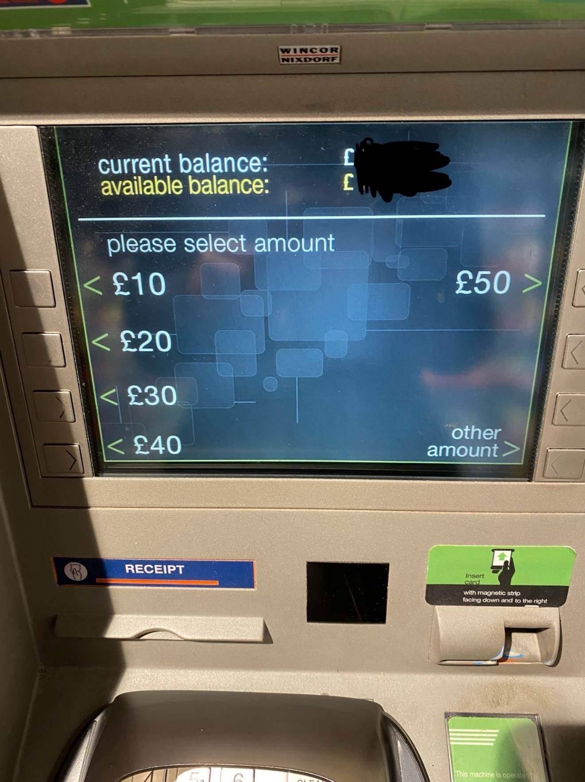

Only allows users to withdraw set amounts. Even when withdrawing other amounts users can only withdraw in multiples of ten which is quite impractical. In my database i hope to allow students to input any amount of money they wish to withdraw as long as it is a whole number.

**Other Services**

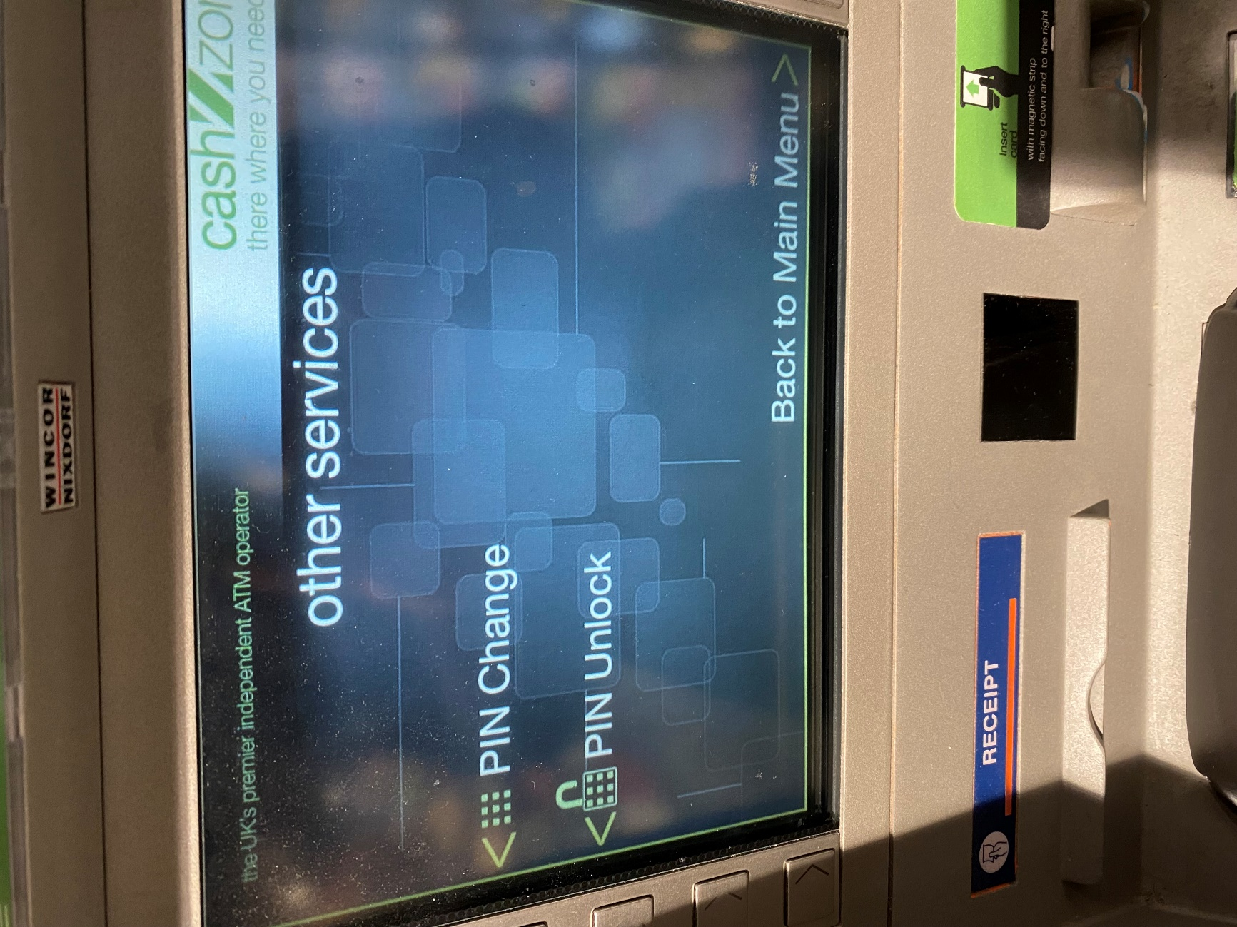

These services are completely unnecessary for the online house bank as the students and the administrator are not going to require PIN to access the website.

**Summary of ATM analysis:**

* Overall the ATM is very simple so there is not a lot of useful analysis. However it would be useful to replicate when viewing the money in house safe and house bank account as the money in the house safe is effectively the current available balance while the current balance is the money in the house safe plus the money in the house bank account.

## Hardware and Software Requirements

#### Hardware Requirements:

* The user should have access to any sort of computer that has access to the internet. For example a mac book or an iPhone. This is because the user needs to be able to access the website.
* I will be using my Microsoft surface Pro to code the website. This is because it is the standard issue computer that my school has given me so it has acess to all of the applications that I need to code my website.

#### Software Requirements:

* I will be using Visual Studio Code to write the code. I will be using this because it is one of the applications provided by the school. Also the program integrates very well with GitHub as it can easily push code straight from visual studio code. Furthermore the application makes using multiple coding languages very easy. It also has highlighting for the syntax of all of the popular coding languages which makes coding much easier. Additionally it is the application that I use to code the most so I am already very used to it.
* I will be using GitHub to upload my code to the cloud. This is because GitHub process of committing code straight from visual studio code is very convenient. Also GitHub allows for other users to access your code easily which makes it easy for my teacher to track my progress.
* I will be using XAMPP to code my web based database locally on my machine. This is because coding the website locally is much easier as my changes automatically get updated so I can check changes my changes or additions much easier rather than having to have my changes saved on an online server. XAMMP also allows me to use MySQL which is what I will be using to manage my database.
* I will be using Award Space to host my website once complete. This is because it is completely free to use and allows me to create a domain for free. Also it allows me to have 1gb of storage and a reasonable number of concurrent users which is more than enough
* Users will need either Microsoft edge or google chrome. This is because house bank will be a website online so they will need to acess it this way.

## Essential Features

* My website will have a login page that allows each pupil to login to view their account or allow the admin to login. This therefore prevents pupils from viewing other peoples bank accounts and separates students from the administrator.
* My website will allow pupils to view their transaction history as this is important to track money being withdrawn from house bank and money added to house back. The administrator will also be able to view student transaction history.
* My website will allow pupils to their own personal balance so that they can see how much money they have left in house bank if they need to add money to house bank.
* My website will allow pupils to put money into house bank and take money out of house bank while updating their personal balances as this will allow the house bank to function.
* The website will allow the administrator to view the current cash balance in the house safe. This is because the administrator needs to know whether they need to withdraw more money from the house bank account as cash in order to pay a pupil. The administrator will also be able to update the cash balance of the house safe.
* The website will also allow the administrator to view and update the house bank account. This will allow the administrator to see how much money they can withdraw from the bank account.
* The administrator will also be able to manage and view every students bank account. This will allow them to see if a student is in debt so that they can notify them.

## Limitations

* The Crosby House bank system will not be linked to actual bank accounts or have any sort of credit card system to transfer money into house bank. This is because it would be too complicated for me to set and testing whether the system is risky especially if using real bank account or credit card details as incorrect amounts of money could be charged to them which would cause large problems. Also the purpose of house bank is too keep cash safe so that it can be withdrawn at a later date. Therefore having bank transfers would defeat the purpose of house bank.
* I will also not be including any sort of SSL security. This is because it is unnecessary as the house bank account system will not contain any sensitive information and will only contain balance numbers. Furthermore, there is also a very low risk of the system being hacked. However, the passwords for the login system will be hashed. Also the high profile SSL security from third party sources is sometimes quite expensive.
* The website will also not allow users to transfer money in between bank accounts. This is because house bank is not meant to be for students to pay each other it is only about keeping large amounts of money in a safe place so having users transfers being able to pay each other is not a necessity.
* Also there will be no automatic updates to either the students or the administrator alerting whether a student has come into debt. This is because these updates could become disruptive and repetitive. Also would be quite hard to implement as it would require using with an external system such as outlook to set up or integrating into windows operating system.
* Another limitation would be the number of users that the system will support. This system will be capped at 70 users. This is because the number of people in Crosby is a maximum of 60 people and is most of the time below this number due to students leaving house. Therefore there is absolutely no situation in which there would need to be more than 70 users and allows for a few extra users if the house expands.

## Success Criteria

1. **Users and Administrator login:** The system will allow at least 5 general and 1 administrator to login to the system with a user name and password. This is to ensure the login system works properly.
2. **Add Users:** users must be added to the system. This is because when people join house they must be added to the system. This must only be able to be done by the administrator
3. **Remove Users:** This is because pupils need to be removed when they leave the house. This must only be able to be done by the administrator.
4. **Hashing Password:** The student and administrator passwords will be hashed when stored. This is to ensure they are kept safe and cannot be intercepted if the system is hacked.
5. **Pupil view Account balance:** Each of the 5 users must be able to view the amount of money in their house bank account. This is because the students need to know how much money is in their account. Also they must not be able to view
6. **Administrator View Pupil Account balance:** The administrator must be able to see the account balance of each of the pupils to see whether they are in debt
7. **Drop Down List for Administrator:** The administrator must be have a drop down list of all of the pupils in the house which he can select a pupil from to view their balance. This will make it much easier for the admin to check all of the student balances.
8. **Withdraw money from house bank:** The students must be able to withdraw money/ request money to be withdrawn from their house bank account balance.
9. **View Transaction History:** Students must able to view their transaction history of all of the money they have withdrawn or deposited into house bank in the past. The administrator must also be able to view each of the students transaction history.
10. **Withdrawal Request Alert:** the administrator must be alerted on the website when the student has withdrawn money from house bank so that they can be paid.
11. **View House Bank Account Balance:** The administrator must be able to view the house bank account balance to see how much money can be withdrawn in cash
12. **View House Safe Amount:** The Administrator must be able to view the amount of cash in the house safe to see if more money needs to be withdrawn from the bank account.
13. **Update House bank account Balance and House Safe amount:** The administrator must be able to update the amount of money in the house bank account or safe.
14. **Automatically Update House Safe amount:** When money is withdrawn from the house bank account both the house bank account and house safe amount will update. When a student deposits money in house bank the house safe amount will also increase. This is because the students cash has been added to the house safe
15. **Student Debt:** Students on the house bank website will be alerted with a red message when they enter debt. This is to ensure that they can then pay the money back when the end of the year comes.